**Army POI Use Case**

**POC: Joetta Kreck – Joetta.l.kreck@usace.army.mil**

**Scenario**

One Army unit is deploying to assist with setting up Covid testing and emergency hospitals while another unit is deploying to a war-torn area where infrastructure has been destroyed and potential hazardous materials may have been released. Each unit has a need for Points of Interest (POI), however these POI will be different depending on the mission and the operational setting. A vast feature data set is available with a complex/robust data schema however these end users are seeking situational awareness for their operation and a geospatial engineer team is responsible for leveraging the feature dataset to generate sets of POI to support each mission. These users only require a limited set of features that are easily represented by intuitive symbols and a select set of attributes that support the mission and can be easily displayed on a mobile device. The end user loads the prepared dataset or connects to a service to cache the POI. The end user reviews POI data over imagery and over a map background to familiarize themselves with on the area. In a sparse area the user will turn on a full set of POI while in dense urban areas the user selects from a list of POI to display.

In both scenarios the users also have a need to collect POI via a simple select the symbol from a list and drop it on the map with a second step of select the symbol from the map and add detail via a drop-down menu with a list of list attributes. The collected and revised POI will be uploaded and validated by the geospatial engineer team and persistent information will be added to the master feature dataset.

**Info from the TC Briefing**

POI for Situational Awareness

* A Point of Interest (POI) can be described in a variety of ways, for this military situation awareness use case, POIs are a simplified set of point features that the user community needs visually represented with options to search, filter, and view labels and attributes. POIs are derived from a more complex geospatial data model and simplified to better enable systems with limited geospatial capabilities. While traditional feature data carries attributes that are often null or contain a “no information” value, POIs should only carry the most relevant and well populated information. In addition to traditional attributes the POI will contains 3 pre-calculate fields that can simplify search, filter, categorize and symbolize the POIs.

POI for Data Collection

* POIs, when combined with an identified symbol set, play a key role in enabling end user data collection. An end user with a known symbol set loaded on a device and a capability to select the icon and place it on the map can perform data collection in the field. The end user may also select the collected symbol and fill form fields with additional details. The collected data may be encrypted and stored on the device, shared across the network, or pushed to the server when connectivity is available.

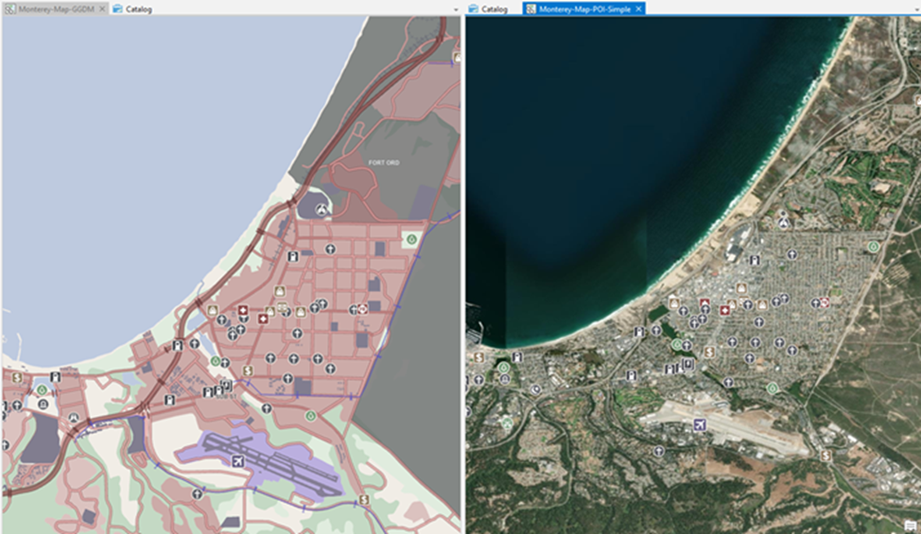

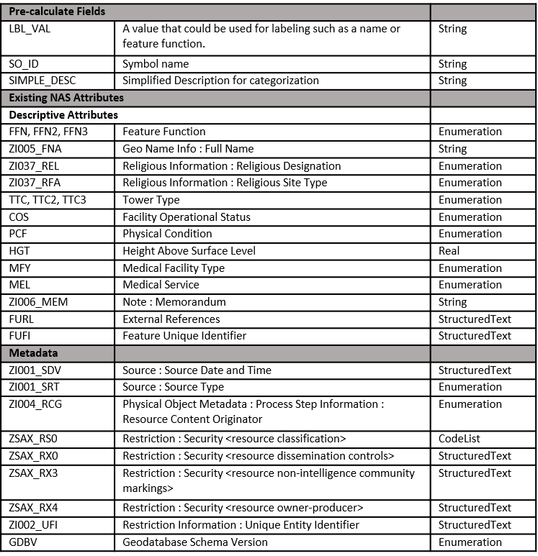

**Use Case: Intuitive Situational Awareness/Understanding**

**Roll: Geospatial Producer (Geospatial Tech/Provisioner)**

**Generating or Importing Data**

* What is needed?/What is interesting?
* Locate POI sources
* Get POI out of a complex data model

Processing

* Cleaning/Filtering/Aggregating

Delivery

* Services
* Cache
* Packages

Consumer Collected Data

* Update with correction
* Add new POIs

**Visualization & Portrayal and Details**

Pre-Process Data

* Select subset from master model
* Priority/Sort order for popups
* Pre-calculated vs complex query

Metadata

* Ensure appropriate Security Metadata
* Populate/Package/Transmit Metadata
* Populate Metadata
* Apply Security Based Filtering

Symbols

* Export/Package/Reference

Style Encoding

* Export/Package/Reference

Use case: Intuitive Situational Awareness/Understanding

Role: Geospatial Producer System Developer

**Geospatial Data/ Preparation & Collection**

Tools, Workflows, Best practices

* POI Dataset Generation
* Extricate POI from complex data models
* Cleaning/Filtering/Aggregating

Metadata – Settings/Population and Export

* Manage Default Security Settings
* Populate/Package/Transmit Metadata
* Permissions based Provisioning
* Security Based Filtering

Visualization

Portrayal and Details

Style File Generation

* Link data to Symbology
* Simplified linking of data to symbols
* Simplified linking labels to Data
* Label – Pre-processing
* Scale Based Filtering
* Prioritization of popup displayed attributes
* Rendering Order

POI Service with style options

* Toggle – All, Sub Group, Single Type, Label
* Filter – Type
* Select and Expand popup
* Change Style
* Import Style

Share Style - Export/Package/Reference

**Use case: Intuitive Situational Awareness/Understanding**

**Role: Geospatial Consumer System Developer**

**Geospatial Data & Preparation & Collection**

Data

* Connect to Service/Load Data
* Link Symbols to data.
* Link attributes to pop-ups
* Link attributes to domain value lookups

Collection

* Drop symbol on map - link Symbol to default attribute set

Form Option:

* Collect from a list of pre-defined attributes (drop downs associated with domain lookup tables)
* Free text to notes field
* Add photo hyperlink

**Visualization & Portrayal Details**

Portrayal and Details

Read and Apply Style File

* Link data to Symbology
* Apply labels to Data
* Scale Based Filtering
* Prioritization of popup displayed attributes
* Rendering Order

Load/Cache/Read Symbol Graphics

Enable Search and Filter

Cluster and Filter Symbols

**Use case: Intuitive Situational Awareness/Understanding**

**Role: Geospatial Consumer**

**Geospatial Data & Preparation & Collection**

Obtain Data

* Connect to Service – Cache Data
* Download Packaged Data

Collect / Update Data

* Collect New POI
* Flag for correction
* Details(Attributes)

**Visualization & Portrayal and Details**

Use POIs for:

* General Position Verification – (Where am I? Am I where I think I am?)
* POI as a start point and end point (routing and general planning)
* Toggle – All, Sub Group, Single Type
* Filter – Type
* Toggle - Labels
* Select Information
* Import Style
* Change Style